**Project Synopsis**

**Project Name:** Jamalo the Sheep

**Project Members:** Muhammad Uzair Amin, Shafay Iqbal, Zain Hassan, Syed Ibrahim Ali Haider

**Project Description:**

We are building a game for which we took inspiration from sheepish and crossy road. The story of the game is that the player controls a sheep who is running away from a hunter and in doing so encounters a street full of cars. Now the sheep has to cross the road to safety within a time limit and without being hit by the cars. The sheep has 3 lives and loses one each time it gets hit by a vehicle, to make the game more immersive powerups have also been added; these include immunity, speed and health. Immunity will grant the sheep immunity from cars for a brief period of time, health will increase the health of the sheep by one and speed will give the sheep super speed for a certain period of time, hence the vehicles will seem slower to the sheep.

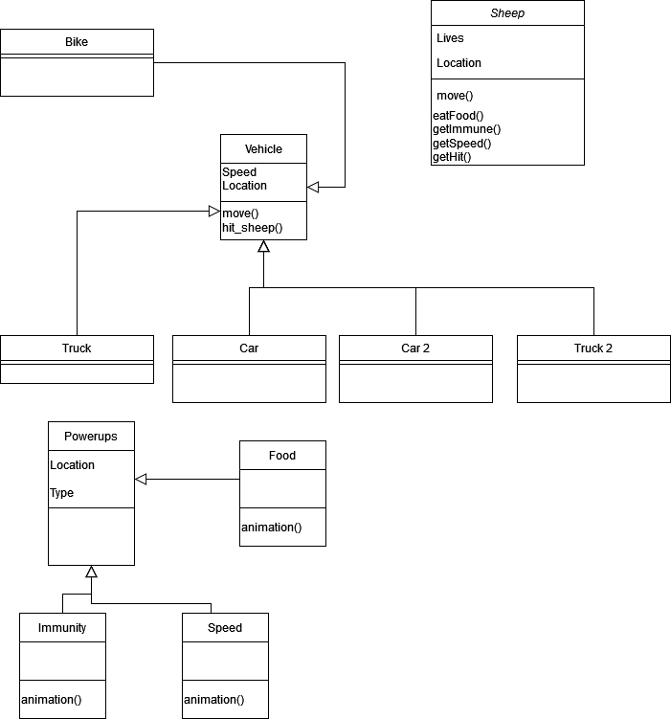

This is the UML of the game, more classes related to SDL and the game will have to be implemented once we start coding. Other than that all the main classes regarding the gameplay have been shown in the above UML.

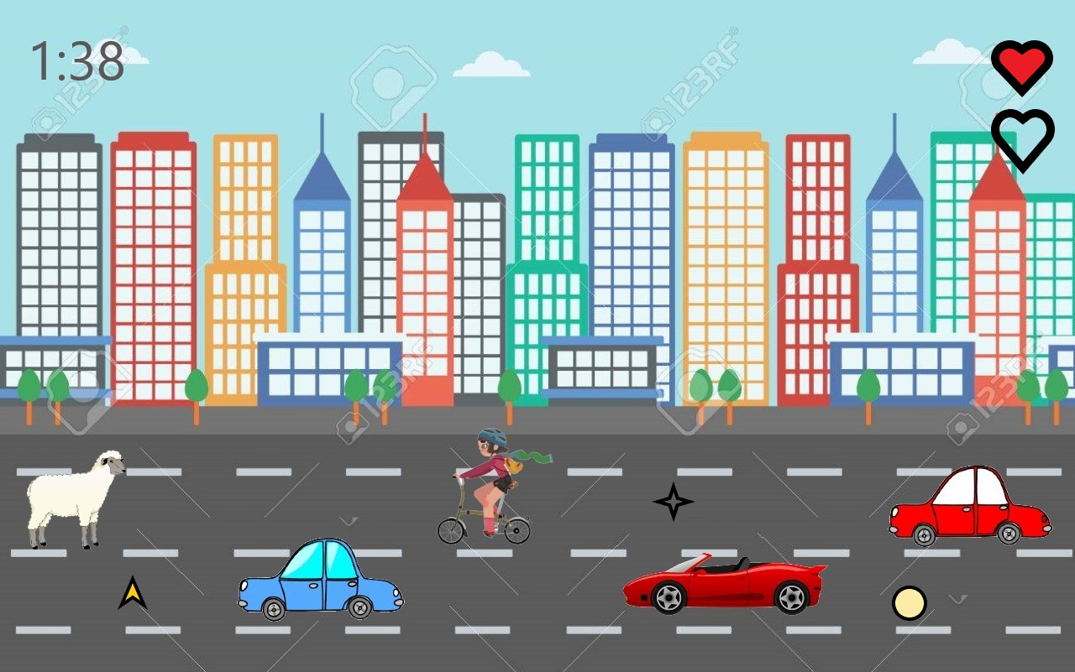

The game screen will look somewhat like this, the picture you are seeing is a tentative design in our minds right now and is subject to some change further down the line. Changes like more lanes, footpaths and such might be implemented